**Year 2 Semester 1 (2025)**

IT2120 - Probability and Statistics Lab Sheet 10

**Lab Exercise 10 - Chi Squared Tests Week 13**

Before starting the lab sheet, you need to create a folder in your desktop and save all your working inside the folder. Set the working directory to that folder using the following command:

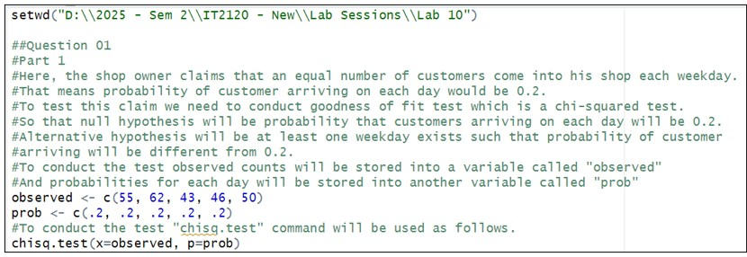setwd("paste the path of the folder")



**FacultyofComputing**

**Eg:-** setwd("D:\\2025 - Sem 2\\IT2120\\Lab Sessions\\Lab 10")

1. A shop owner claims that an equal number of customers come into his shop each weekday. To test this hypothesis, a researcher records the number of customers that come into the shop in a given week and finds the following:

Monday: 55 customers

Tuesday: 62 customers

Wednesday: 43 customers

Thursday: 46 customers Friday: 50 customers

* 1. Conduct a suitable Chi-square test to check the claim of shop owner.
  2. Write your conclusion based on test results.

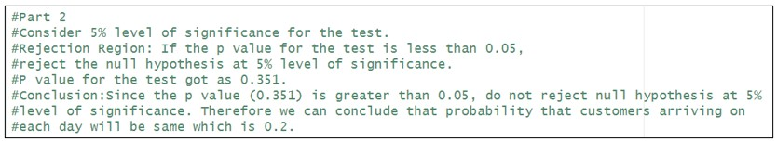

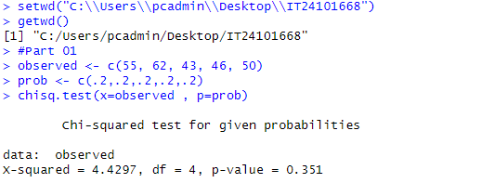

1. Consider the house tasks data set in the path, [http://www.sthda.com/sthda/ RDoc/data/housetasks.txt](http://www.sthda.com/sthda/RDoc/data/housetasks.txt) which contains contingency table with 13 house tasks and their distribution in the couple. An image of the data is displayed below:

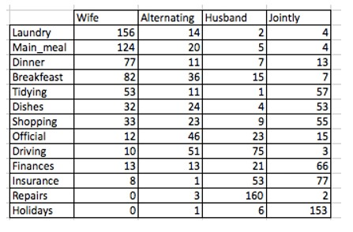

Here rows are the different tasks, values are the frequencies of the tasks done: by the wife only, alternatively, by the husband only or jointly.

* 1. Import the data into R.

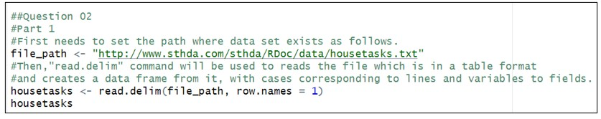

* 1. Test whether there is any association between house tasks and their distribution in the couple.

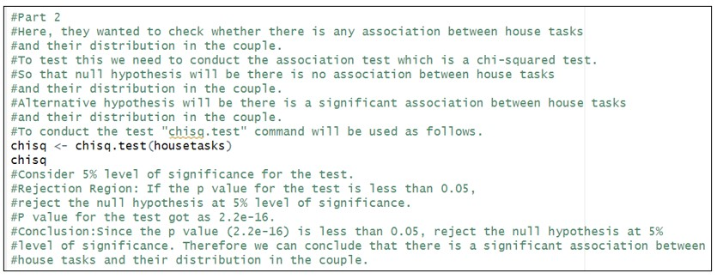

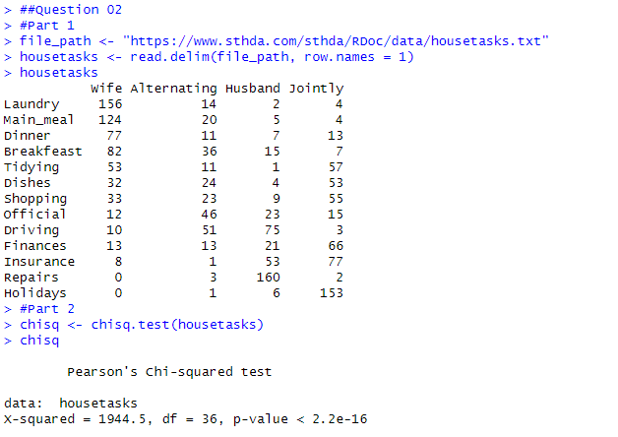

# Exercise

**Instructions**: Create a folder in your desktop with your registration number (Eg: ”IT.......”). You need to save the R script file and take screenshots of the command prompt with answers and save it in a word document inside the folder. Save both R script file and word document with your registration number (Eg: ”IT........”). After you finish the exercise, zip the folder and upload the zip file to the submission link.

1. A vending machine owner claims that customers choose the four snack types (A, B, C, D) with equal probability. To test this claim, a researcher records the number of purchases for each snack type during one week and results are given below.

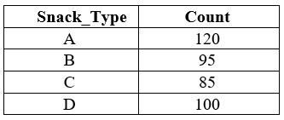

1. State the null and alternative hypotheses for the test.
2. Perform a suitable chi-squared test to test the null hypothesis. iii. Give your conclusions based on the results.

